## **Website Functionalities**

## **1: Homepage**

The PlatScreens website's homepage is the main page from which users can access all other pages, and the content and features it offers. Users can proceed from this point to the login page, the contact us page, movie information, ticket buying, viewing movie detail, and other pages. The homepage has a comfortable and user-friendly design that includes high-quality photos, detail of each and every movie, linked trailers, and much more. It strives to provide customers with a visually appealing and straightforward experience, allowing them to easily navigate the movie options and access all the provided services functions.

## **2. Search Movies**

Screenshot of webpage:

Within this movie ticket booking website, consumers may easily search for and browse movies using the Search page. This page has an easy-to-use search box where users can enter the titles of movies to discover what they're looking for quickly. Users may find the right movie as they write because the search tool suggests movies in real time and shows cover photos and titles that match.

Clicking on a recommendation takes the visitor to a page with comprehensive movie details. This website has all the information you might possibly need to know about the chosen film, including a summary, cast list, showtimes, and reservations. Users can easily go from looking for a movie to checking its details and making a reservation thanks to the smooth navigation.

Both a mouse and a keyboard can be used to easily navigate the search feature. To choose the first movie that matches, users can either click on the suggested movies or hit the Enter key. Because of its adaptability to various user preferences, the search experience is easy to use and accessible to all people.

The search feature uses AJAX on the backend to give users a fluid and dynamic experience. An AJAX request is sent to retrieve matched movie titles from the database when users input in the search field. Users are guaranteed to obtain prompt reply on their inquiries as the search results are thereafter shown in real-time. The Movie Ticket Booking system's entire user experience is improved by this effective and engaging search procedure.

## **3. Dark/Light Mode for All Webpages**

Screenshot of webpage:

**Dark Mode Example:**

## User firsts launch the website, everything will be displayed in dark mode. However, users can switch between themes for a customized experience using the dark/light mode toggle, the reason for this additional feature was to ensure that the passionate light mode users do not have any sort of discomfort. Furthermore, for convenience, this toggle is situated in the navigation bar for each and every page in the website. The active class on different components is dynamically updated by the JavaScript code when it is clicked, causing associated CSS alterations to change the mode. This thorough covering guarantees that, in either dark or light mode, the interface maintains its visual coherence and appeal.**4. Arrows for Horizontal Scrolling Through Movie Listings (on Homepage)**

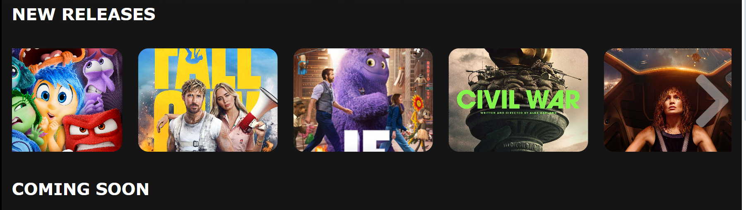

The arrow function allows viewers to scroll through movie lists horizontally, which improves their browsing experience. When users click the arrow icons, the movie list slides smoothly, revealing more movies that would otherwise be hidden off-screen. This feature is very handy for displaying a high number of movies in a small space while without bombarding the user with excessive content at once.

The JavaScript code manages the scrolling behaviour by estimating the number of visible movie components and modifying the scroll position accordingly. If the list reaches the finish, it resets to the beginning to ensure a smooth and uninterrupted browsing experience. This feature is visually enhanced by the CSS design of the arrow symbols, which make them visible and easy to interact with.

## **5. Login/Register**

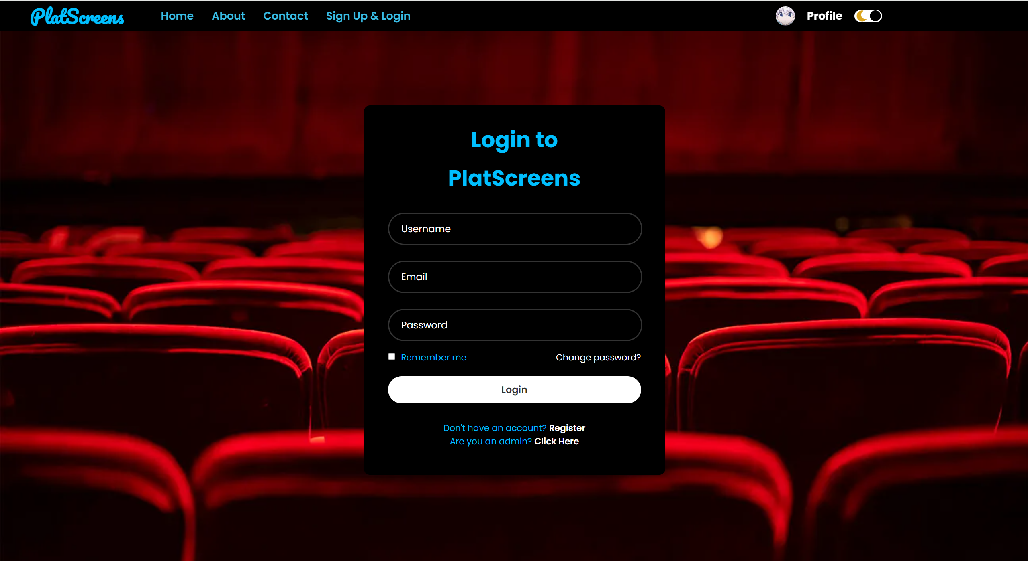

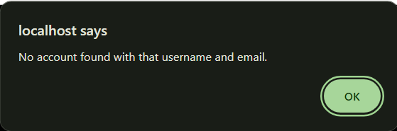

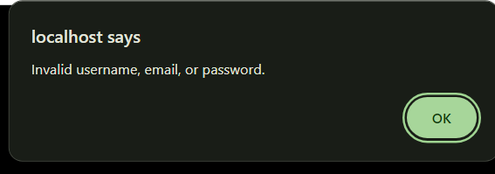

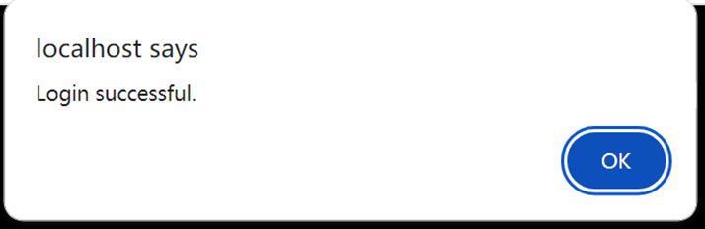

In the Login page, users need fill out all the account login information, which include Username, Email, Password, to login successfully. This greatly increases and protects the user's personal information security and personal account security.

If the users provide a username or email that is not registered before, then it will pop up “no account found” error messages.

If the users provide wrong password but the system found the email and username, it will pop up “invalid password” error messages.

After users provide correct password, email and username, then the system will prompt "Login Successful" and automatically jump to the Home Page.

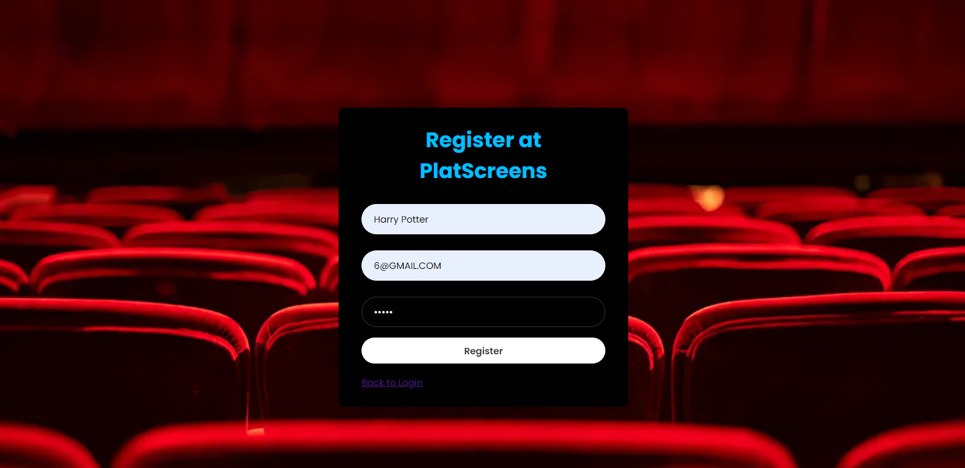

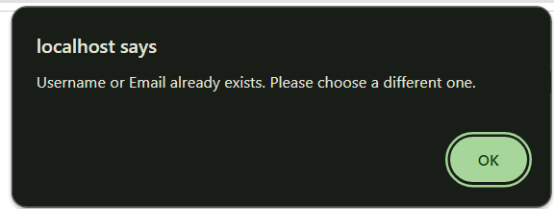

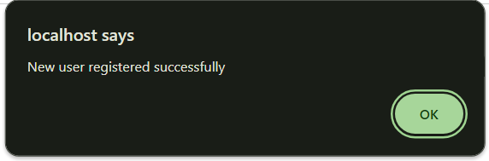

New users can register by clicking the Register text below. If the new user registers a new account but with the same email or username, there will be a pop-up alert message that prompts users to choose a different email or username. Until the new user provides a new email and new username that are not duplicate with other users, then it will show register successfully. Then it will automatically go back to the Login Page to facilitate the user to log in after registration.

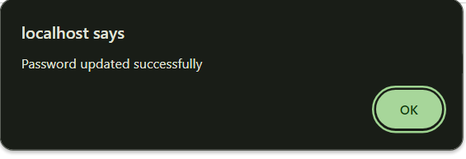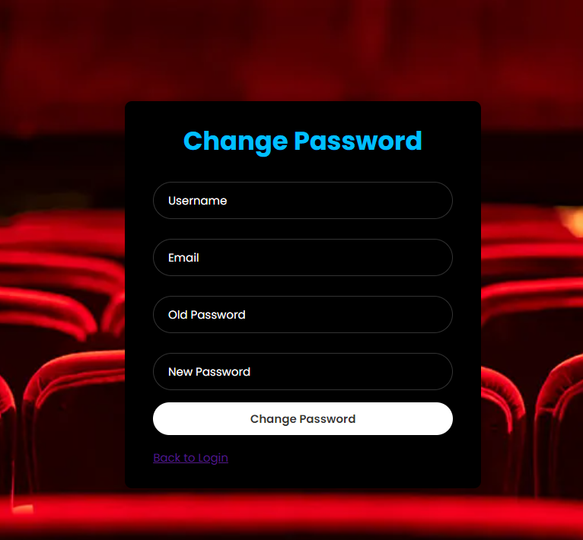

If users forget their password, they can change it by clicking Change Password. To change the password, they need to provide correct Username, Email, Old Password and New Password. This ensures the security of their account. Users must provide the correct old password, otherwise it will pop up an error message and show “error for update password” message. After providing the correct old password, our database will automatically update the user's new password. And the system will indicate that the password has been successfully changed and jump back to the Login page.

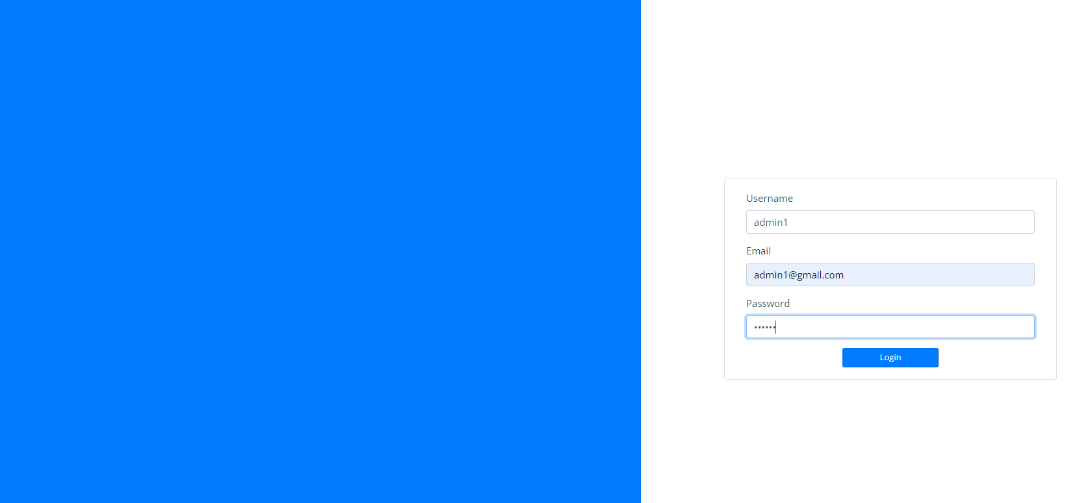

For admin login, they can just click “Click here” from the login page, then it will direct them to this admin login page.

The Admin Login page offers admins with a secure portal to the Movie Seat Booking system's backend. This page has a basic, easy to use form that requests the username, email address, and password for login. After login in, the form data is transferred via AJAX to be processed, where the credentials are validated against the database. If the login information is accurate, the user gets sent to the main administrator panel; they otherwise receive an error message for incorrect credentials.

## **6. Admin Dashboard Page**

1. **Admin Movie List Page**

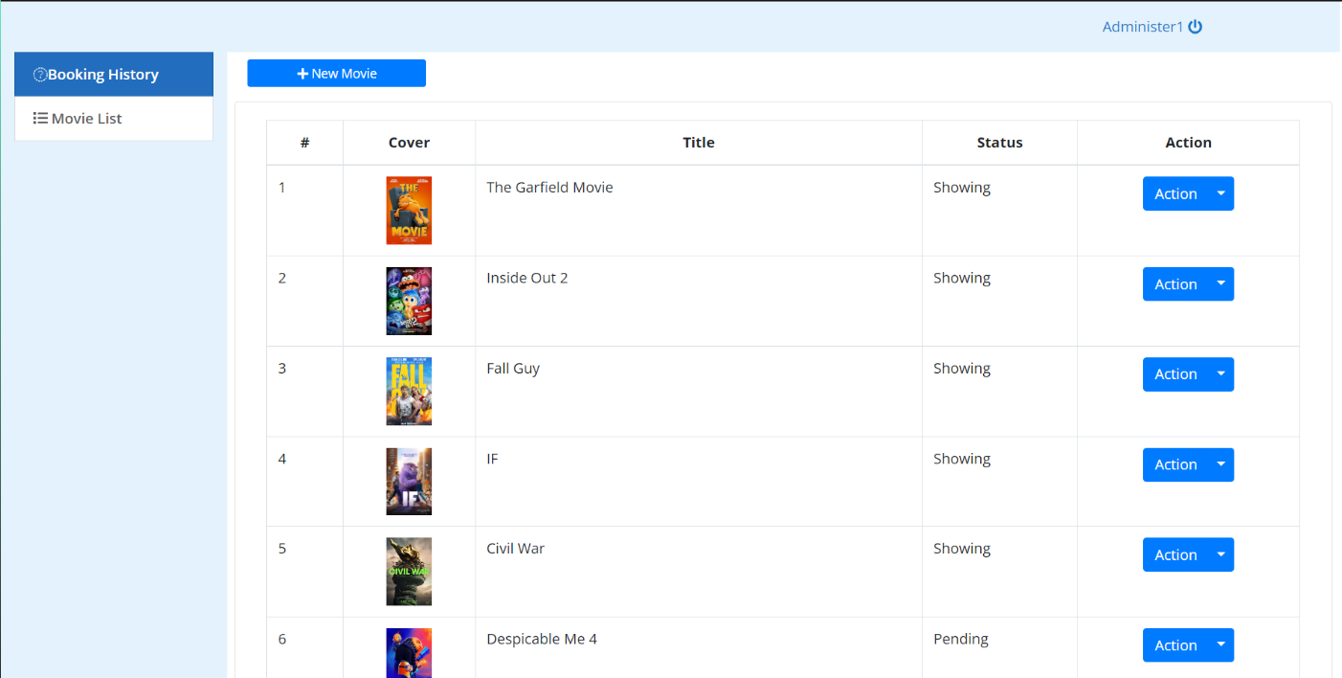After admin logging in successfully, admins are taken to the Admin Movie List page. This page acts as the main hub for maintaining movie records. The interface shows an extensive list of all films in the system, along with tools to add, amend, and delete movie entries. Each movie record includes key characteristics such as its title, genre, and showtimes, giving the administrator a rapid overview. The side bar provides extra access to other admin operations, as well as a logout button at the top right corner.

1. **Admin Booking History**

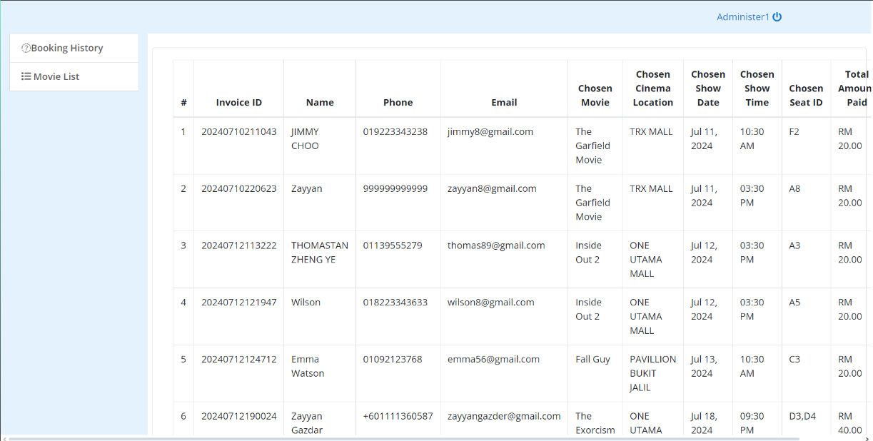

The Admin Booking Record page includes a full record of all seat bookings made by clients. This page is critical for tracking and maintaining customer bookings, to guarantee the booking process goes well. Each booking entry contains important information such as the movie title, seat group, client name, contact number, booking date and time, and payment method. The page enables the admin to efficiently examine and handle all reservations.

1. **Adding New Movie Option**

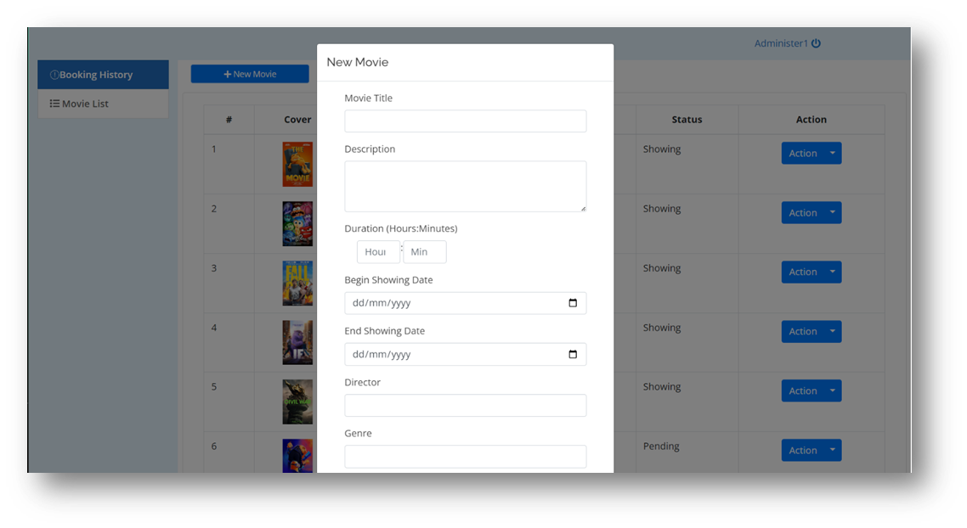

The Adding New Movie area allows admins to enter all of the details needed to create new movie entries. The form provides fields for the film's title, description, length, showtime dates, and many more options. Administrators can also upload a cover and picture of the background for the movie. The form data is processed using AJAX, which ensures that the freshly released film information is saved in the database and quickly shown on the movie list page. This functionality allows administrators to easily keep the movie offers up to date

1. **Edit/ Delete Movie**

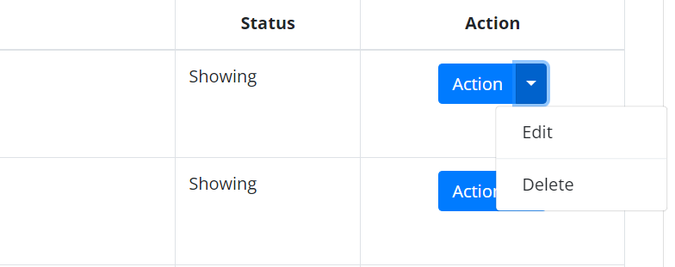

Admins can use the Edit/Delete Movie Content capability to change or delete current movie entries. By selecting a movie from the list, administrators have access to a form identical to the 'Add New Movie' page, which is already filled with the film's current information. Modifications can be made to any of the movie's details, and updates are handled via AJAX. The confirmation window guarantees that films are not deleted mistakenly. This feature guarantees that the movie database is correct and up to date, reflecting the most recent information and eliminating outdated items.

## **7 About Us**

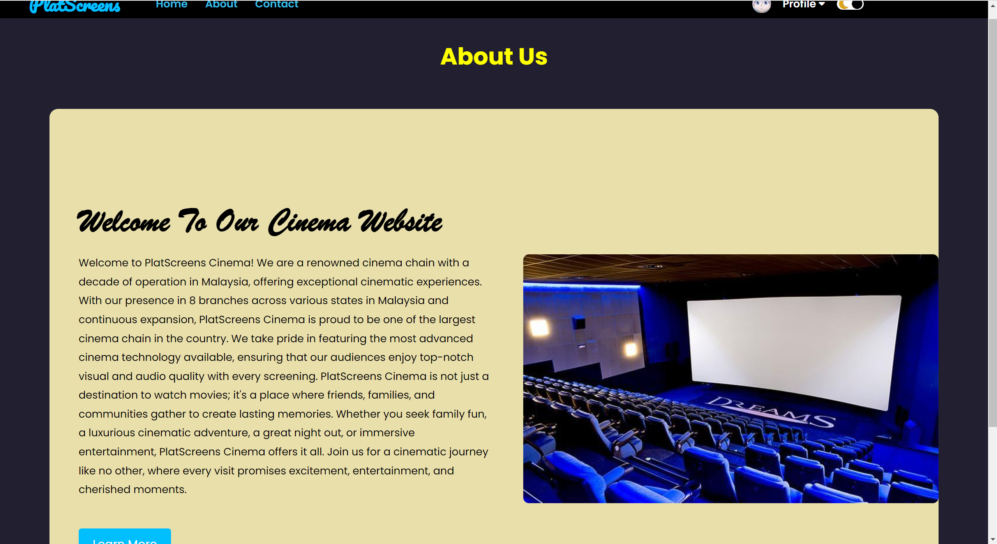

This is an about us page which introduces our cinema introduction, describing the benefits and reasons for users choosing our cinema. We have added flashing pages to catch the user's eye. If the user wants to know more, they can click on the 'learn more' button, then they will be taken to the YouTube video of our cinema to learn more about our cinema story and visions.

## **8: Movie details pages**

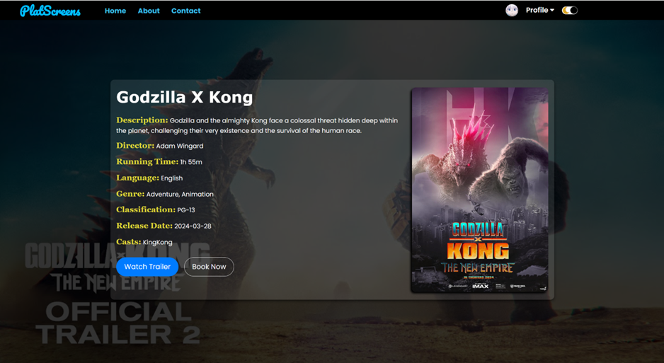

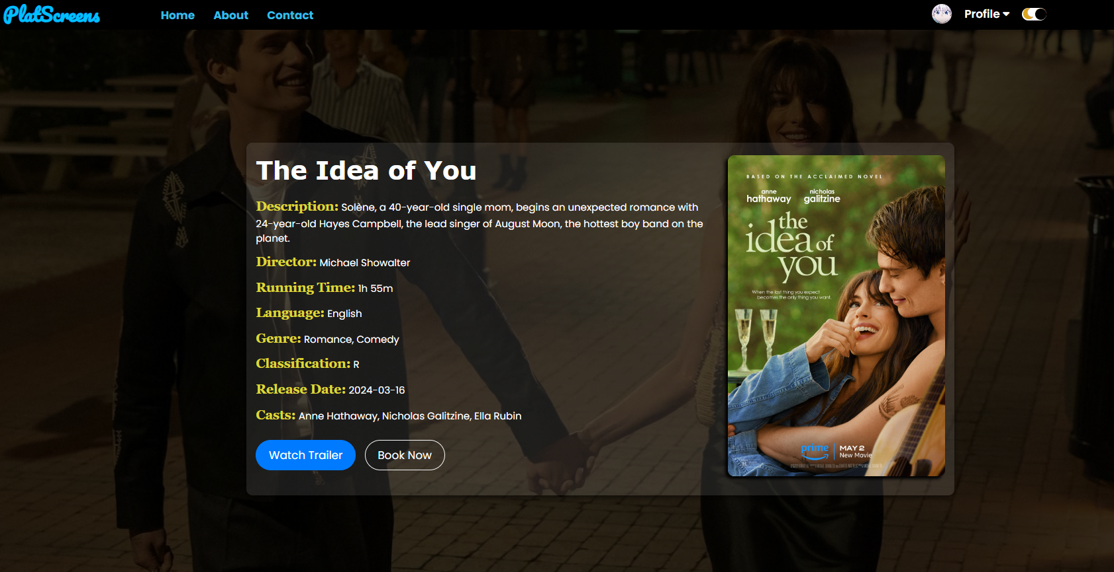

In the Home Page users can see a wide range of films, each of which can be clicked on to view the movie details page.

**At this movie details:**

It includes the poster, release date, synopsis, film length, film language, film classification, director, and cast. Users can see the details of the film intuitively and clearly, which saves users' time to understand the film and get the film they want to see and captures users' psychology and increases the probability of buying tickets.

All these movie details and pictures are fetched from our database, which allows the movie details to be updated dynamically based on the retrieved movie data from database.

The watch Trailer at the bottom can be clicked and jumped directly to the film trailer on YouTube.

From this page, after clicking ‘Book Now” user can purchase tickets directly and jump to the **seat selection page**.

## **9: Movie Seat Booking (Seat Selection)**

Screenshot of webpage:

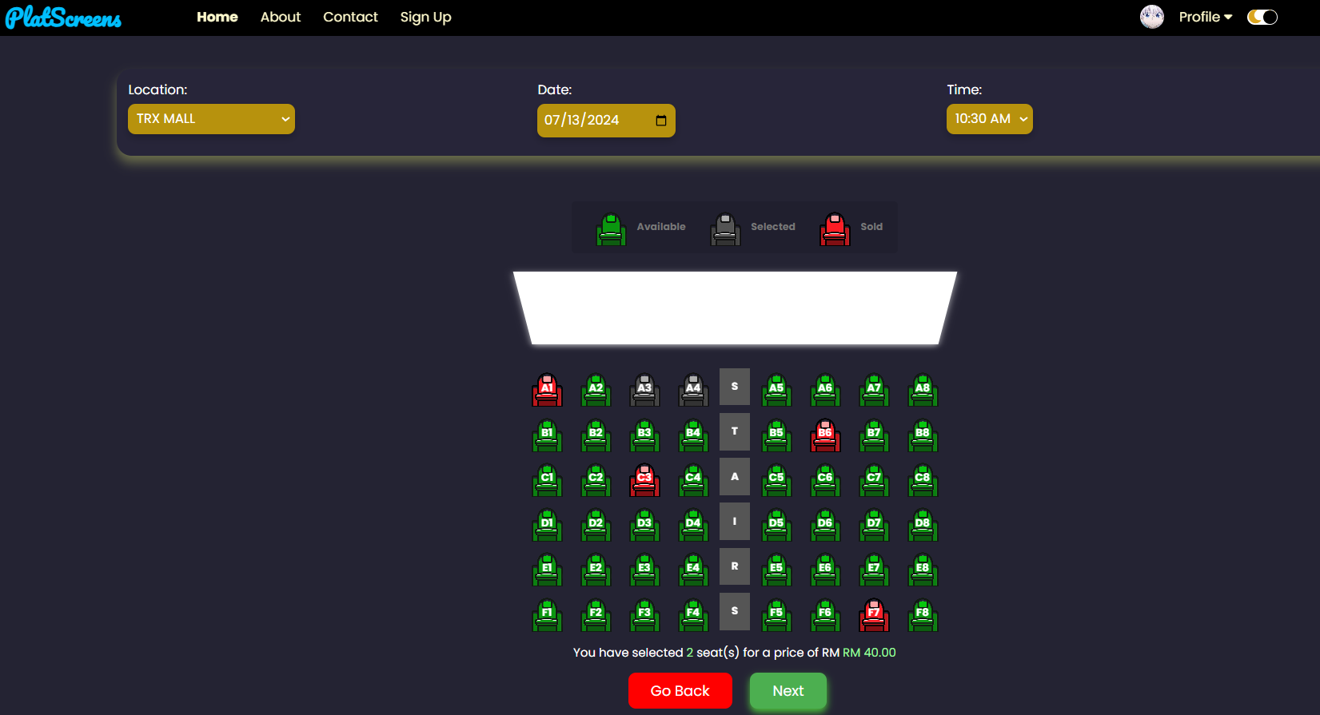

On the Movie Seat Booking Page, users can easily book movie tickets by selecting their preferred location, date, time, and seat number. The booked seats are indicated in red color and cannot be selected, while the available seats are highlighted in green for user selection. Once a user chooses a green seat, it will change to grey to signify their selection. At the bottom of the page, a text displays the number of selected seats and the total price. After selecting their desired seats, users can proceed to payment by clicking the "Next" button. If they wish to return back to the View Movie Details Page, they can simply click the "Go Back" button.

The layout design of this page is created using HTML and CSS. We use red color to represent as the sold seat, we use green color to represent as the available seat, and we use grey color to represent as the user selected seat. These three colors picked for their specific function are industry standards. These color choices align with common practices in various industries to convey specific meanings and statuses of the 3 different seat categories.

Once the user selects their preferred seat, the "Next" button changes from grey to green, prompting the user to proceed with the payment by clicking the “Next” button.

## **10. Payment Confirmation Form**

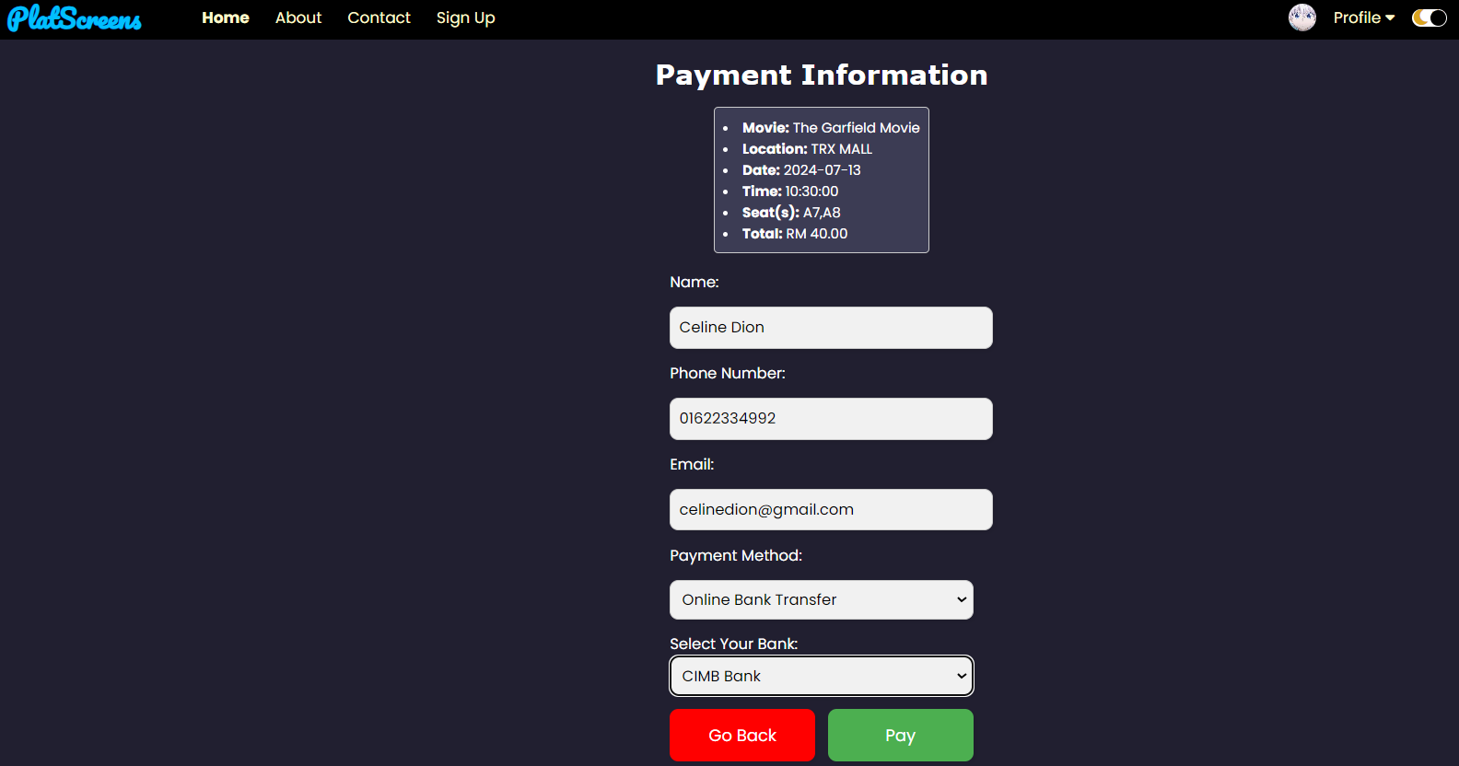

After the user clicks the "Next" button on the Movie Seat Booking Page, they will be directed to the Confirm Payment Page. On this page, users can review all the details of their booked movie tickets. They will then need to fill in all the boxes and provide payment information in order to proceed with the payment. Users have the flexibility to choose their preferred payment method, including options such as PayPal, Online bank transfer, or Touch 'n Go. Then, if they choose to click the "Pay" green button, they will be directed to the Payment Gateway Demo Page. Alternatively, users can also go back to the Movie Seat Booking Page by clicking the "Go Back" red button.

The layout design of this page is created using HTML and CSS. The choice of red colour for the "Go back" button but green colour for the "Next" button is based on psychology and standard design practices. Red is often associated with negative actions such as stopping and cancelling, while green is commonly linked with positive actions like confirmation and proceeding. Moreover, we provide a drop-down list box that letting users to select their payment method.

## **11. Payment Gateway Demo**

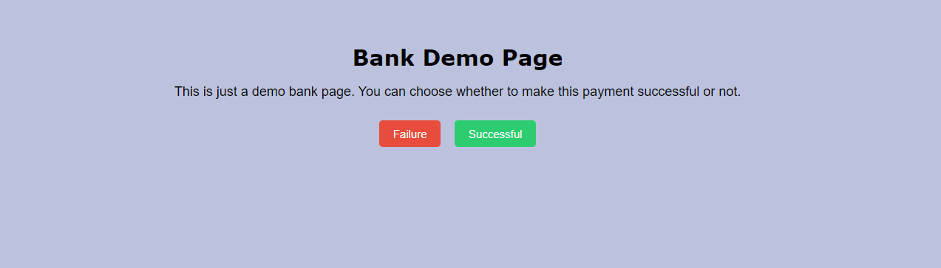

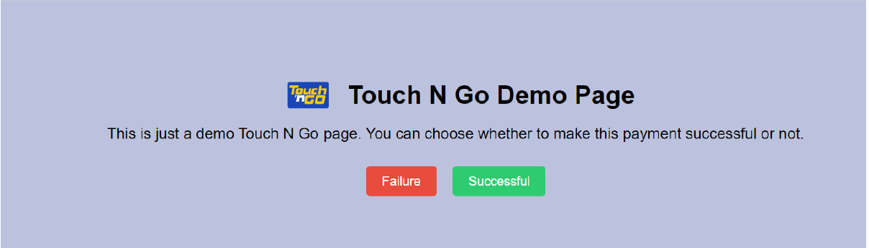

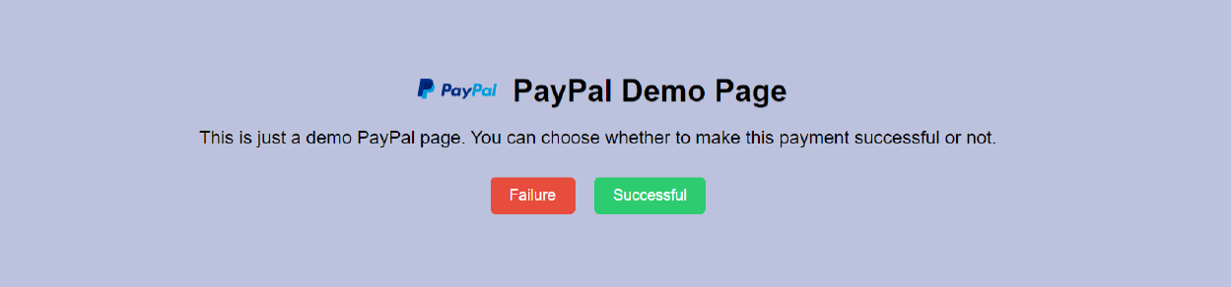

When users have selected their payment method and clicks the "Pay" button on the Confirm Payment Page, they will be directed to the respective demo page based on the payment option chosen (PayPal Demo Page / Bank Demo Page/ Touch 'n Go Demo Page).

On this demo page, they will experience a demo where they can choose between a successful or failed payment options. If they select "failure" red button, a pop-up message will indicate an unsuccessful payment, redirecting them back to the homepage. Conversely, selecting "successful" green button triggers a confirmation message for a successful payment and directs them to the receipt page. Additionally, the status of the selected seats will be updated to "sold" after user have clicked "successful" button. At the same time, the booking details will be stored into the “booking_info” table in our database.

## **12. Receipt of Payment**

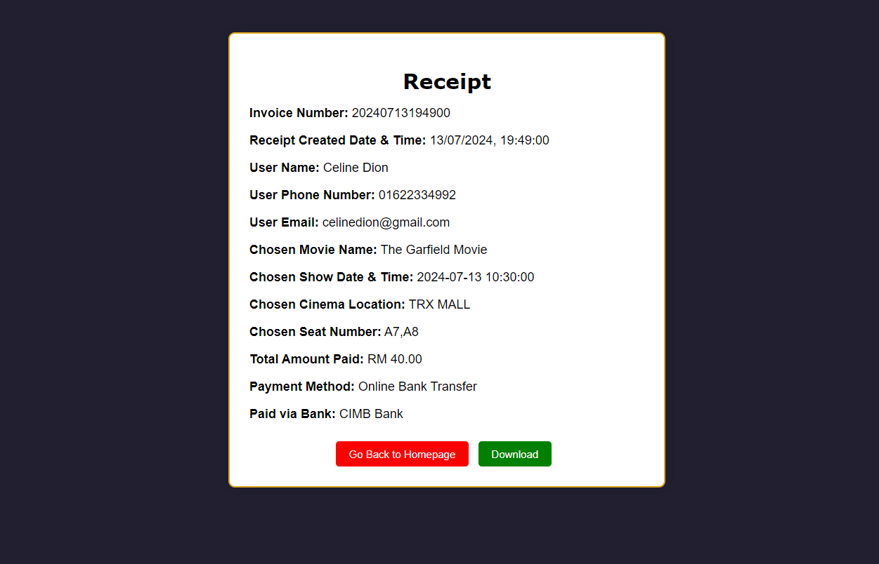

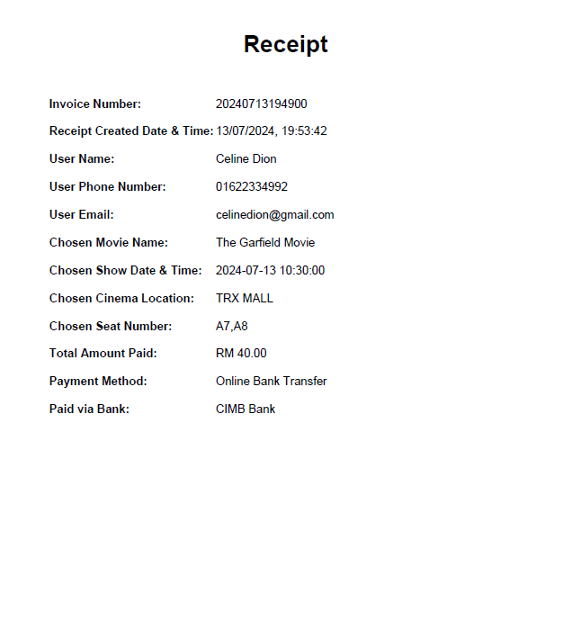

On the Receipt Page, users are allowed to view and check all the details of the booked movie ticket after they have made payment successfully. They can choose to download the receipt in pdf file for further reference.

## **13. Contact Us Page (Customer Service Form)**

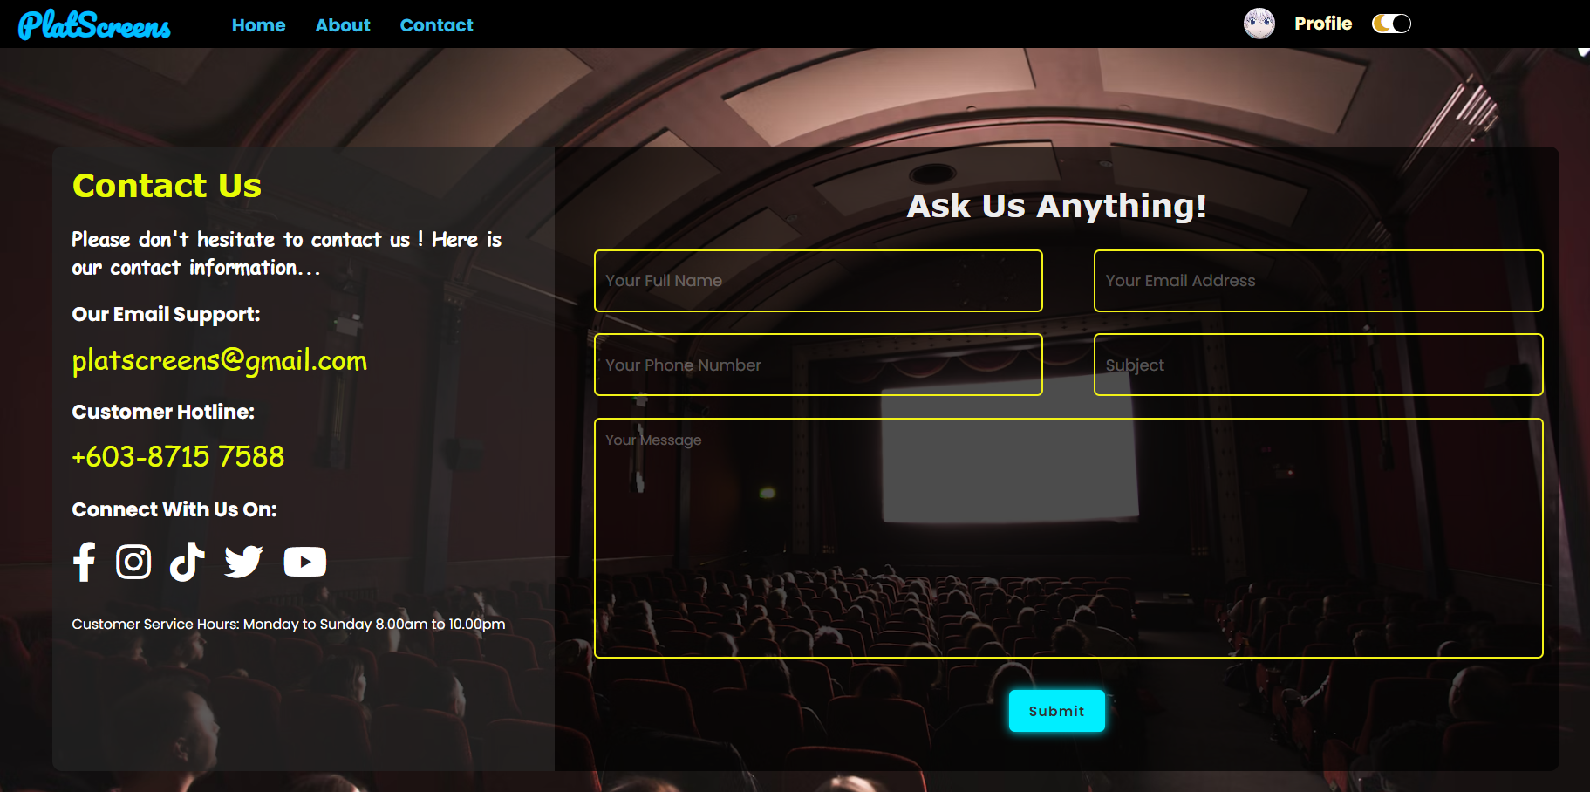

If you need further assistance, click the "Contact" button on the homepage.

This will take you to our Contact Us Page, where you'll find multiple ways to reach us.

First, we have our email support and customer hotline listed there for your convenience.

Additionally, users can click on the social media icons to be redirected to the respective social media pages for further communication.

On the Customer Service Form page, users can submit the service form to the admin email through the Email JS third-party service. All fields in the form must be completed. Otherwise, a prompt will guide users to fill in any missing information.